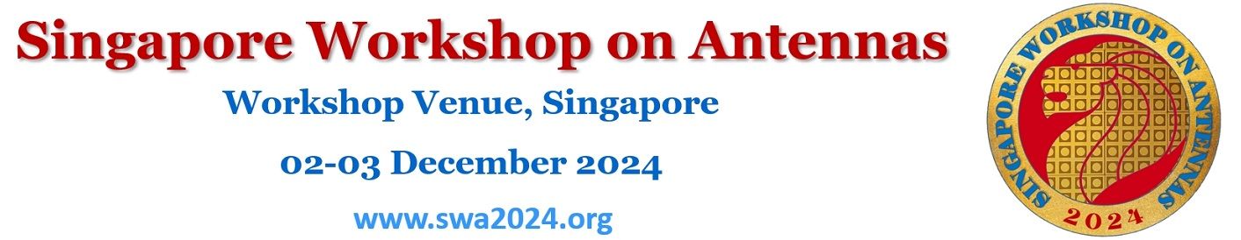

**SWA2024 Registration Form**

Note: Please fill in the **YELLOW** table cells.

|  |  |  |  |  |  |  |  |
| --- | --- | --- | --- | --- | --- | --- | --- |
| **Name** |  | | | **Title** | | Prof./Dr./Mr./Ms. | |
| **Affiliation** |  | | | | | | |
| **Email** |  | | | | | | |
| **Office Phone** |  | | **Mobile Phone** | |  | | |
| **Registration Fee** | **Regular Registration** (with 1 banquet ticket) | | | | | **SGD 400.00** | |
| **Student Registration** (without banquet ticket) | | | | | **SGD 200.00** | |
| **Number of Additional Banquet Ticket(s)** | | | | | **SGD 100.00** each | |
| **Total Amount** | Registration Fee  + Number of Additional Banquet Ticket × SGD 100 | | | | | **SGD** |  |
|  | | | | | | | |
| **Your Choice** (tick one below) | **Payment Methods/Instructions** | | | | | | |
| **( )** | 1. **Online Bank Transfer:**   Please send a copy of bank transfer receipt together with this Registration Form to [TSLLiuz@nus.edu.sg](mailto:tslliuz@nus.edu.sg) . Payment, identifying Presenting Author name, should be wired to the following bank account information: | | | | | | |
| *Account Name:*  *Account Number:*  *Bank name:*  *Bank Address:*  *SWIFT Code:* | **Exomnia Events Pte Ltd - SG Antenna Workshop**  **072-103681-9**  **DBS Bank Singapore**  **12 Marina Boulevard, DBS Asia Central,  Marina Bay Financial Centre Tower 3,  Singapore 018982**  **DBSSSGSG** | | | | | |
| **( )** | 1. **By Cheque**   Please post your cheque together with this Registration Form to  Exomnia Events Pte Ltd - SG Antenna Workshop  50 Ubi Avenue 3, #03-13 Frontier, Singapore 408866 | | | | | | |
| **( )** | 1. **By Cash**   Please indicate this method if you wish to make payment in cash on site during workshop days | | | | | | |
|  | | | | | | | |
| **Banquet Food Option** | Choose one please:  International ( ), Halah ( ), Vegetarian( ). | | | | | | |
| **Any Note** |  | | | | | | |